
SCHOOL OF COMPUTING AND ENGINEERING SCIENCES (SCES)
BACHELOR OF SCIENCE IN ELECTRICAL AND ELECTRONICS ENGINEERING (BSEEE)
BEE 3206: CONTROL SYSTEMS_1 Lab 1
GROUP 5
Report By:
Mwongela Edward Aribu
142092

LECTURER: PROF. MWANGI MBUTHIA
LABORATORY TECHNOLOGIST: MR. JAMLICK NTOJIRA
17th September 2023

Contents
List of figures 2
Title 3
Abstract 3
Introduction 3
KS0559(KS0559F) Keyestudio 4WD BT Multi-purpose Car V2.0 3
Methods and Materials 4
Robot car weight 4
Robot car maximum steady state road speed in m/s 5
Method 1: Using Micro-Controller 5
Method 2: Stopwatch application 6
Determine at least 5 values of acceleration from rest to the maximum steady state road speed. 6
Robot Car Direction and Speed Control 7
Determine the Direction of the Robot Car 7
Stop the Robot Car 8
Turn the Robot Car 8
Robot Car Direction and Speed Control 9
Results 10
Determine the robot car weight 10
Determine the robot car maximum steady state road speed in m/s 11
Measure at least 5 values of acceleration from rest to maximum steady state road speed 12
Plot the acceleration values on a graph paper 12
Code that will accelerate the robot car the maximum speed and drive it for a distance of 5 metres, turn the car through 180 degrees, drive to maximum speed and stop the car after another 5 metres. 12
Discussion 15
Conclusion 15
References 15

List of figures
Figure 1 GY-271 Triple Axis Compass Magnetometer 7
Figure 2 10
Figure 3 10
Figure 4 10
Figure 5 10
Figure 6 11

Title
Determine Car Acceleration, Direction and Steady State Speed

Abstract
- When writing an abstract, try to answer these questions:
  - Why was the research done or experiment conducted?
  - What problem is being addressed?
  - What results were found?
  - What are the meaning of the results?
  - How is the problem better understood now than before, if at all?
Objective:
- Measure the maximum steady state road speed and direction of a robot car
- Measure the acceleration of a driverless robot car

Introduction

KS0559(KS0559F) Keyestudio 4WD BT Multi-purpose Car V2.0

The KS0559(KS0559F) Keyestudio 4WD BT Multi-purpose Car V2.0 is one of the most popular Arduino sets. It has a stunning appearance as well as powerful functions. Furthermore, you can build your own projects or add other sensors to finish your research. Most of the components are connected by screws and copper pillars, allowing you to build your own robot in a few simple steps. Furthermore, we may master the fundamentals of line tracking, obstacle avoidance sensors, ultrasonic ranging, Bluetooth connection, motor drivers, and IR remote controls. This bundle includes 17 learning projects ranging from simple to sophisticated that will walk you through the process of building an Arduino robot.(KS0559(KS0559F）Keyestudio 4WD BT Multi-Purpose Car V2.0 - Keyestudio Wiki, n.d.)
Its features include:
- Multi-purpose function: Obstacle avoidance, following, IR remote control, Bluetooth control, confined with a circle, gravity control as well as facial emoticons display.
- Simple assembly: No soldering circuit required, simple assembly.
- Sturdy construction: 4WD construction, 4 premium motors and wheels.
- High extension: It can expand other sensors and modules via a motor driver expansion board.
- Multiple controls: IR remote control, App control (iOS and Android system)
- Basic programming：C language code of Arduino IDE.
Its specifications include:
- Working voltage: 5V
- Input voltage: 6-9V
- Maximum output current: 2A
- Maximum power dissipation: 25W (T=75℃)
- Motor speed: 5V 200 rpm
- Motor drive mode: DRV8833 motor driver
- Ultrasonic induction angle: <15 degrees
- Ultrasonic detection distance: 2cm-400cm
- Infrared remote-control distance: 10M (measured)
- Bluetooth remote control distance: 50M(measured)
- Bluetooth control: support Android and iOS system
Its possible project paths include:
- LED Blink
- Adjust LED Brightness
- Line Tracking Sensor
- Servo Control
- Ultrasonic Sensor
- IR Reception
- Bluetooth Remote Control
- Motor Driving and Speed Control
- Facial Expression LED Board
- Restricting Smart Car
- Line Tracking Smart Car
- Ultrasonic Following Smart Car
- Ultrasonic Obstacle Avoidance Smart Car
- IR Remote Control Smart Car
- Bluetooth Control Smart Car
- Bluetooth Speed Control Smart Car
- Multi-purpose Bluetooth Smart Car

Methods and Materials

Robot car weight
- List Robot Car Components:
Create a detailed list of all the components or parts that make up the robot car. This list should include items like the chassis, motors, sensors, batteries, and any additional components.
- Measure Individual Component Weights:
For each component in the list:
  - Place the weighing scale on a stable surface.
  - Ensure the scale is set to the desired units (e.g., kilograms or grams).
  - Carefully place the individual component on the scale.
  - Record the weight measurement accurately.
- Ensure that all weight measurements are in the same unit (e.g., kilograms or grams). Convert measurements to a consistent unit if necessary.
- Record Measurements
Record the weight of each component in a table or spreadsheet. Include the component's name or description alongside its weight.
- Sum Component Weights:
Calculate the total weight of the robot car by summing the weights of all individual components using the following formula:
Total Weight = Weight of Component 1 + Weight of Component 2 + ... + Weight of Component N

Robot car maximum steady state road speed in m/s

Method 1: Using Micro-Controller

- Install Wheel Encoder:
Ensure that the wheel encoder is correctly installed on one or more of the robot car's wheels. It should be securely attached and able to count wheel rotations accurately.
- Determine Wheel Circumference:
Measure the circumference of the wheel(s) to which the encoder is attached. This measurement is crucial for converting encoder counts into distance.
- Initialize Microcontroller:
Set up your microcontroller and programming environment for data acquisition and processing.
- Reading Encoder Data:
Write code to read data from the wheel encoder. Typically, wheel encoders produce pulse or count data that indicates wheel rotations.
- Calculate Distance Travelled:
Using the encoder counts and the wheel circumference, calculate the distance travelled by the robot car since the last measurement. The formula is:
Distance = (Encoder Counts / Encoder Resolution) * Wheel Circumference
Where:
Encoder Counts: The number of pulses or counts from the encoder.
Encoder Resolution: The number of counts per revolution of the wheel encoder.
Wheel Circumference: The circumference of the wheel.
- Time Measurement:
Record the time elapsed between encoder readings. This will be used to calculate speed.
- Calculate Speed:
Calculate the speed of the robot car by dividing the calculated distance travelled by the time elapsed between measurements. The formula is:
Speed = Distance / Time
- Logging Data:
Log the speed data along with timestamps for analysis.

Method 2: Stopwatch application
- Set Up the Test Track:
Choose a straight and level track where you can safely operate your robot car. This track should have a known distance or be easily measured.
- Mark the Start and End Points:
Mark the starting point (S) and the ending point (E) on the track. Ensure that the distance between these two points is accurately measured or known.
- Prepare the Robot Car:
Ensure that the robot car is in working condition and ready to operate.
- Zero the Stopwatch:
If your stopwatch has a zeroing function, make sure to reset it to zero before starting the measurement.
- Start the Stopwatch:
Position yourself at the starting point (S) with the stopwatch in hand.
- Release the Robot Car:
Carefully release the robot car from the starting point, allowing it to move freely.
- Stop the Stopwatch:
As soon as the robot car crosses the ending point (E), stop the stopwatch.
- Record the Time:
Record the time it took for the robot car to travel from point S to point E. This time represents the travel time over the known distance.
- Calculate Speed:
Calculate the speed of the robot car by dividing the known distance by the recorded travel time. The formula is:
Speed = Distance / Time

Determine at least 5 values of acceleration from rest to the maximum steady state road speed.
- Calculate the acceleration of the robot car using the following formula, which relates initial speed, final speed, and time:
Acceleration (a) = (Vf - Vi) / Time

Robot Car Direction and Speed Control

Determine the Direction of the Robot Car
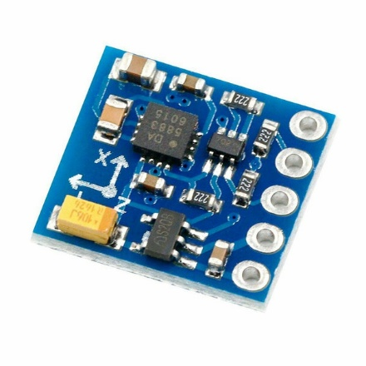
Figure 1 GY-271 Triple Axis Compass Magnetometer

- Mount the Magnetometer Sensor:
Ensure that the magnetometer sensor is correctly mounted on the robot car. The sensor should be positioned so that it can measure the Earth's magnetic field without interference from other magnetic sources.
- Initialize the Microcontroller:
Set up your microcontroller and programming environment for data acquisition and processing.
- Install and Configure Magnetometer Library.
- Calibrate the Magnetometer
- To improve accuracy, you may need to calibrate the magnetometer sensor. This involves:
  - Placing the robot car in a magnet-free environment, free from magnetic interference (e.g., away from electronic devices and metal objects).
  - Running a calibration routine in your code to measure the sensor's offset and scaling factors.
  - Apply these calibration values to your magnetometer readings to correct for any bias or scaling errors.
- Read Magnetometer Data:
Write code to read data from the magnetometer sensor. Magnetometer sensors typically provide measurements in three axes: X, Y, and Z. These measurements represent the strength and direction of the Earth's magnetic field.
- Calculate Heading Angle:
Use the magnetometer data to calculate the heading angle. The heading angle is typically calculated using the arctangent function to determine the angle between the magnetic North and the direction of the robot car's heading. The exact calculation depends on the sensor's orientation and coordinate system.
- Convert Heading Angle to Degrees:
If the angle is calculated in radians, convert it to degrees for easier interpretation. The conversion formula is:
Heading (degrees) = Heading (radians) * (180 / π)
- Display or Use Heading Information:
Display the calculated heading angle on a screen, send it wirelessly to a remote device, or use it for navigation and control algorithms.

Stop the Robot Car
- Reverse Polarity to the Motor then Zero Voltage
  - In reverse the polarity (positive to negative, negative to positive), the current flows in the opposite direction, causing the motor to spin in the opposite direction or, in many cases, come to a stop.
  - Zero voltage stops any movement.
- PWM Control Unit at 0% Duty Cycle:
With 0% PWM duty cycle and reverse polarity applied, there is no power to drive the motor, and it remains stationary.

Turn the Robot Car
- Calculate Distance for Inner and Outer Wheels:
Determine whether you are turning the robot car to the right or left.
- Measure the wheelbase (D) of the robot car, which is the distance between the axles.
- Calculate the turning radius (R) based on the desired angle of turn (Theta).
- R = D / (2 * tan(Theta / 2))
- Calculate the distances for the inner and outer wheels based on the turning direction:
If turning right (inner wheels are the right wheels, outer wheels are the left wheels):
Distance for inner wheels (d_inner) = (R - D/2) * Theta
Distance for outer wheels (d_outer) = R * Theta
- If turning left (inner wheels are the left wheels, outer wheels are the right wheels):
Distance for inner wheels (d_inner) = (R + D/2) * Theta
Distance for outer wheels (d_outer) = R * Theta
- Calculate Distance Required for the Turn:
- Determine the desired angle of turn (Theta) in radians.
- Calculate the distance required for the turn based on the turning radius (R) and the angle of turn (Theta):
Distance_required = R * Theta
- Monitor Distance Using Wheel Encoders:
Continuously update the distances traveled by the inner and outer wheels as they move.
Stop the robot car when the calculated distances (d_inner or d_outer) are reached.
- Use the Magnetometer for Feedback:
Initialize the magnetometer sensor and set it up to provide heading information.
Continuously read and update the heading (direction) provided by the magnetometer.
Compare the current heading with the target heading for the desired turn.
Adjust the motor speeds and steering to maintain the correct heading and direction during the turn.
Use feedback from the magnetometer to make real-time adjustments and ensure accurate navigation.

Parameters |  | r_B (m) | r (m) | r_A (m)
Car Width (m) | 0.12 | 0.44 | 0.5 | 0.56
Outer Wheel PWM | 213 | arc_B (m) | arc (m) | arc_A (m)
Direction | L | 1.382301 | 1.570796 | 1.759292
Angle (1 to 360) | 180 | B_PWM |  | A_PWM
Turn Radius (m) | 0.5 | 167.3571 |  | 213
Wheel Circumference |  | 1.25 | 200
 |  | 1 | 163
 |  | 1.25 | 1.226994

Wheel | Encoder
Holes | Blocks
16 | 16

Robot Car Direction and Speed Control
Write down in detail the methods you will use to achieve the following;
i) Determine the direction of the robot car
ii) Stop the robot car
iii) Turn the robot car

Results

Determine the robot car weight
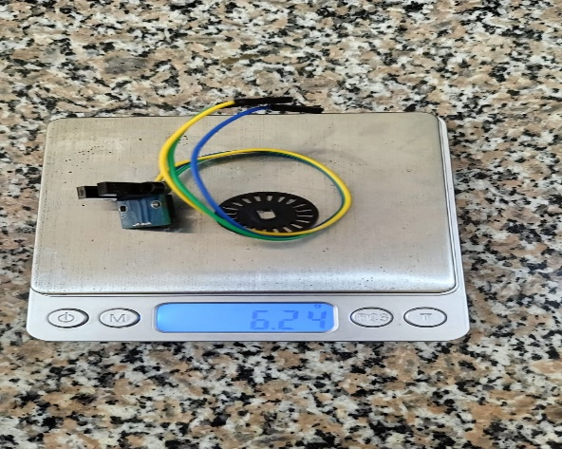
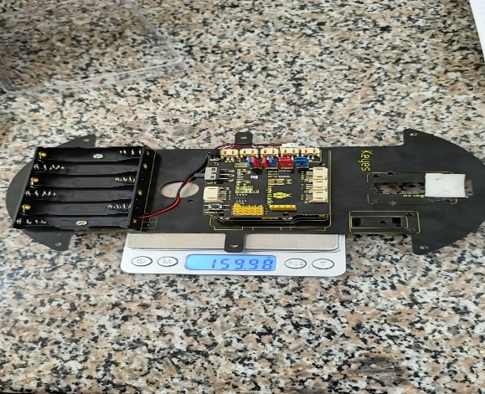
Figure 2
Figure 3

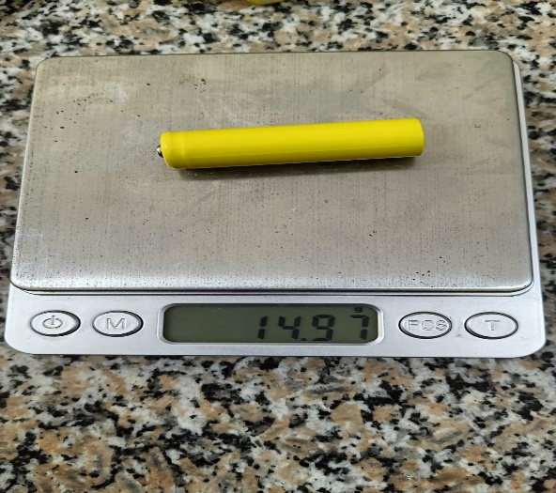
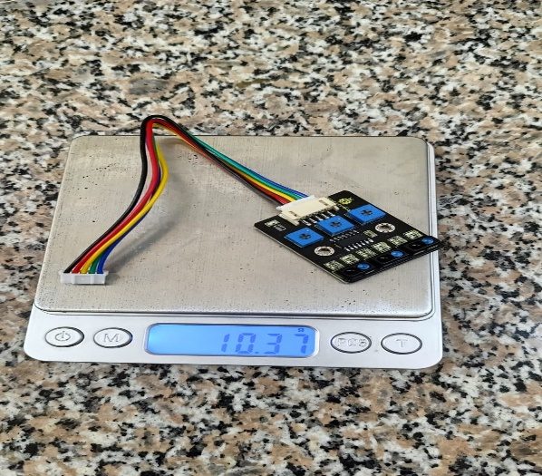
Figure 4
Figure 5

item | mass(gm)
wheel (4) | 143.33
motor | 40.46
motor | 40.26
motor | 40.47
motor | 40.21
Motor driver+ Battery holder+ Top Board | 159.98
Line Tracking Sensor | 10.37
LED Matrix | 22.5
Battery (6) | 89.2
Bottom Board+ screws+ copper bush | 114.09
Wheel Encoder | 6.24
Total | 707.11
Figure 6

Determine the robot car maximum steady state road speed in m/s

Timestamp | Second | Seconds | Time Taken(s) | Distance (m) | Speed (m/s) | Acceleration
14:55:20.379 | 20.379 | 53720.379 | 0.115 | 0.0204 | 0.2758 | 2.39826087
14:55:20.494 | 20.494 | 53720.494 | 0.122 | 0.0204 | 0.2758 | 0
14:55:20.616 | 20.616 | 53720.616 | 0.08 | 0.0204 | 0.2758 | 0
14:55:20.696 | 20.696 | 53720.696 | 0.123 | 0.0204 | 0.3225 | 0.58375
14:55:20.819 | 20.819 | 53720.819 | 0.082 | 0.0204 | 0.3225 | 0
14:55:20.901 | 20.901 | 53720.901 | 0.074 | 0.0204 | 0.3225 | 0
14:55:20.975 | 20.975 | 53720.975 | 0.121 | 0.0204 | 0.3225 | 0
14:55:21.096 | 21.096 | 53721.096 | 0.082 | 0.0204 | 0.3225 | 0
14:55:21.178 | 21.178 | 53721.178 | 0.041 | 0.0204 | 0.3225 | 0
14:55:21.219 | 21.219 | 53721.219 | 0.081 | 0.0204 | 0.3225 | 0
14:55:21.300 | 21.300 | 53721.3 | 0.121 | 0.0204 | 0.3225 | 0
14:55:21.421 | 21.421 | 53721.421 | 0.164 | 0.0204 | 0.3339 | 0.09421488
14:55:21.585 | 21.585 | 53721.585 | 0.122 | 0.0204 | 0.3339 | 0
14:55:21.707 | 21.707 | 53721.707 | 0.08 | 0.0204 | 0.2917 | -0.3459016
14:55:21.787 | 21.787 | 53721.787 | 0.041 | 0.0204 | 0.2917 | 0
14:55:21.828 | 21.828 | 53721.828 | 0.082 | 0.0204 | 0.3346 | 1.04634146
14:55:21.910 | 21.910 | 53721.91 | 0.081 | 0.0204 | 0.3346 | 0
14:55:21.991 | 21.991 | 53721.991 | 0.123 | 0.0204 | 0.3262 | -0.1037037

WHEELS ON THE TRACK
Mark (m) | Second | Speed (m/s) | Acceleration
0 | 1 | 0.16666667 | 0.16666667
0.5 | 4 | 0.16666667 | 0
1 | 7 | 0.16666667 | 0
1.5 | 11 | 0.125 | -0.0104167
2 | 14 | 0.16666667 | 0.01388889
2.5 | 17 | 0.16666667 | 0
3 | 20 | 0.16666667 | 0
3.5 | 24 | 0.125 | -0.0104167
4 | 27 | 0.16666667 | 0.01388889
4.5 | 30 | 0.16666667 | 0
5 | 34 | 0.125 | -0.0104167

0.16666667 m/s

Measure at least 5 values of acceleration from rest to maximum steady state road speed

Plot the acceleration values on a graph paper

Code that will accelerate the robot car the maximum speed and drive it for a distance of 5 metres, turn the car through 180 degrees, drive to maximum speed and stop the car after another 5 metres.

#include <Wire.h>
#include <Adafruit_MotorShield.h>
#include <Adafruit_Sensor.h>
#include <Adafruit_BNO055.h>
#include <utility/imumaths.h>
// Create instances of the motor shield and distance sensor
Adafruit_MotorShield AFMS = Adafruit_MotorShield();
Adafruit_DCMotor *motor1 = AFMS.getMotor(1);
Adafruit_DCMotor *motor2 = AFMS.getMotor(2);
Adafruit_DCMotor *motor3 = AFMS.getMotor(3);
Adafruit_DCMotor *motor4 = AFMS.getMotor(4);
const int echoPin = 2; // Ultrasonic sensor echo pin
const int trigPin = 3; // Ultrasonic sensor trigger pin
const float cmToMeters = 0.01; // Conversion factor for cm to meters
void setup() {
AFMS.begin();
Serial.begin(9600);
pinMode(trigPin, OUTPUT);
pinMode(echoPin, INPUT);
}
float getDistance() {
digitalWrite(trigPin, LOW);
delayMicroseconds(2);
digitalWrite(trigPin, HIGH);
delayMicroseconds(10);
digitalWrite(trigPin, LOW);
return pulseIn(echoPin, HIGH) * cmToMeters / 58.0; // Calculate distance in meters
}
void accelerateToMaxSpeed() {
motor1->setSpeed(255); // Set motor speed to maximum
motor1->run(FORWARD);
motor2->setSpeed(255);
motor2->run(FORWARD);
motor3->setSpeed(255);
motor3->run(FORWARD);
motor4->setSpeed(255);
motor4->run(FORWARD);
}
void driveForDistance(float distanceMeters) {
float initialDistance = getDistance();
float traveledDistance = 0;
while (traveledDistance < distanceMeters) {
// Drive forward
accelerateToMaxSpeed();
// Calculate the traveled distance
float currentDistance = getDistance();
traveledDistance = initialDistance - currentDistance;
}
// Stop the motors
motor1->setSpeed(0);
motor2->setSpeed(0);
motor3->setSpeed(0);
motor4->setSpeed(0);
}
void perform180DegreeTurn() {
// Implement code to make the robot turn 180 degrees.
// This can involve stopping one side of the motors while keeping the other side running.
}
void loop() {
// Accelerate to maximum speed
accelerateToMaxSpeed();
// Drive for 5 meters
driveForDistance(5);
// Perform a 180-degree turn
perform180DegreeTurn();
// Drive for another 5 meters
driveForDistance(5);
// Stop the motors
motor1->setSpeed(0);
motor2->setSpeed(0);
motor3->setSpeed(0);
motor4->setSpeed(0);
}

Discussion
- When writing a discussion, try to answer these questions:
  - What do the results indicate?
  - What is the significance of the results?
  - Are there any gaps in knowledge?
  - Are there any new questions that have been raised?
What objectives were achieved in your practical experiment?
Learning Outcome:
- Understand how to determine the road speed of a car
- Understand how to use sensors to measure the acceleration and direction of a car
- Control speed and direction of a robot car

Conclusion

References
KS0559(KS0559F）Keyestudio 4WD BT Multi-purpose Car V2.0—Keyestudio Wiki. (n.d.). Retrieved October 8, 2023, from https://wiki.keyestudio.com/KS0559(KS0559F%EF%BC%89Keyestudio_4WD_BT_Multi-purpose_Car_V2.0

